How to Brew Persian Tea

*by*MY PERSIAN KITCHEN*on DECEMBER 4, 2009*

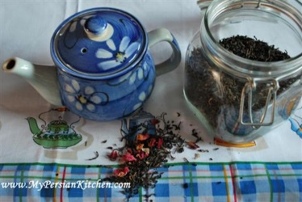

Any Persian will tell you that they love to drink *Chai*, pronounced

Cha-ee.  Tea, in general, is what Persians drink in the morning, after each meal, and not to mention throughout the day.  Additionally, the first drink that one if offered when visiting someone else’s home is usually tea.  Iranians make tea in their own way which I will demonstrate in this post.  Personally, I see this ritual as an art.

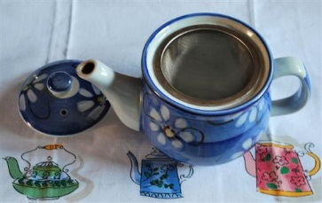

All you need is a nice teapot,

loose tea, and a pinch of rose petals.

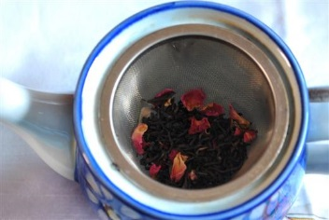

I like to use a mesh tea infuser to

keep the leaves from going onto the cup.

You don’t have to use one…

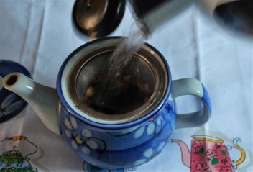

Place a couple of generous pinches of

loose tea and one pinch of rose petals

in the teapot.

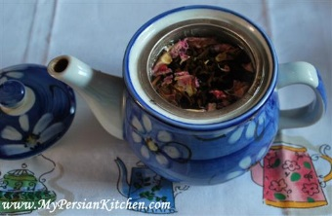Add boiling water.

Cover and let steep for about 5 to 10 minutes.

Persians will usually place the teapot on top of the

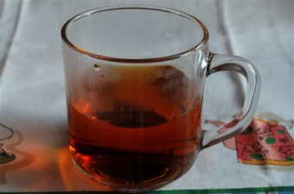kettle whie it simmers on the stove in order to keep

the tea warm.

Here comes the Persian way of pouring tea. First pour some of the hot tea into the cup to check its color. It must be somewhat dark. Then pour the tea back into the tea pot. This will do two things: 1) it will warm up the cup and 2) it moves the tea inside the teapot around so that color of the tea is even.

If the color is light, let steep for a little longer. Then fill up one third to half of the cup with tea.

Pour hot water over it. And Voila! You have Persian tea!

Note, Persians always drink their tea in see through glass cups.  This allows the person who pours the tea determine the consistency and color of the tea. A good Persian host will always ask his or her guests how strong or light they like their tea. Some people like their tea dark and strong, while others like it on the light side.